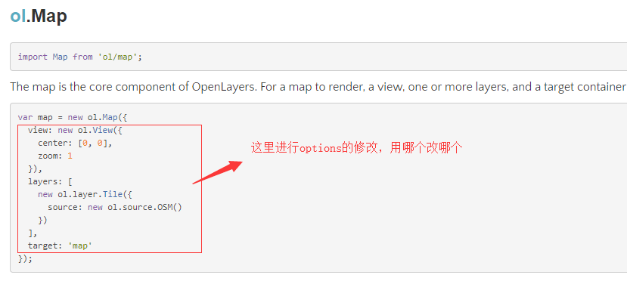

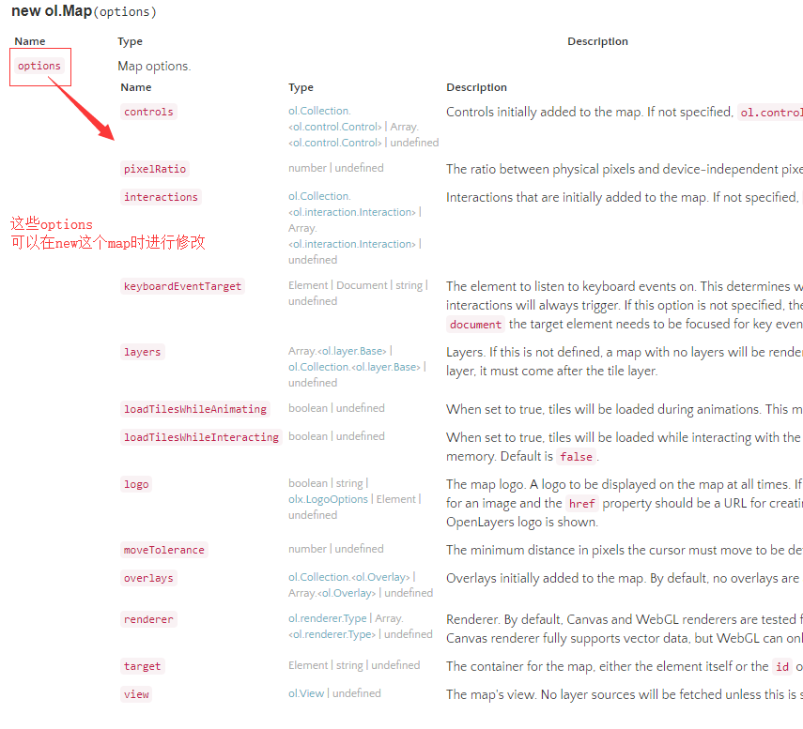

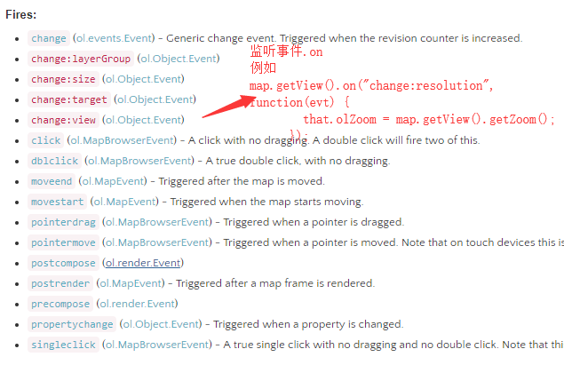

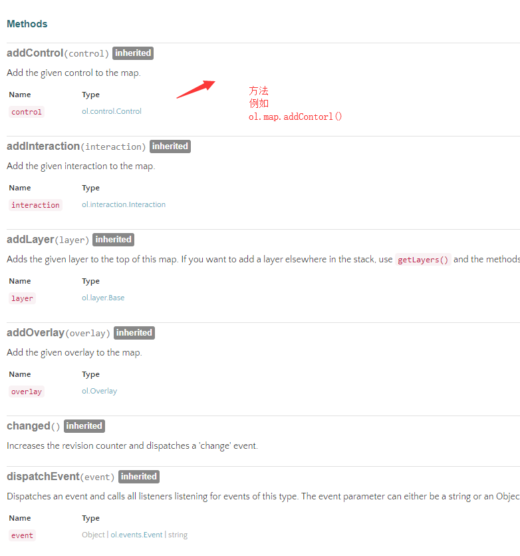

map = new ol.Map({

//修改options 用哪个改那个

target: document.getElementById("id-map"),

controls: ol.control

//默认项

.defaults({

attribution: false,

zoomOptions: {

zoomInTipLabel: "放大",

zoomOutTipLabel: "缩小"

}

})

//扩展项 已经在initMap() 中定义

.extend([fullScreenControl, mousePositionControl, overviewControl]),

interactions: ol.interaction.defaults({

//双击放大

doubleClickZoom: true

}),

//可视化区域view

view: new ol.View({

projection: "EPSG:4326",

center: ol.proj.transform([127.43, 45.01], "EPSG:4326", "EPSG:4326"), //初始默认中心点

zoom: 4, //初始默认缩放级数

minZoom: 2,

maxZoom: 22

})

});

map.getView().on("change:resolution", function(evt) {

that.olZoom = map.getView().getZoom();

});